Intelligent Predictive Maintenance for Smart Building Systems

Yojana Naik  
*Department Of* *Artificial Intelligence*  
*Vishwakarma University*Pune, India  
nyojana25@gmail.com  
Yashashree Bedmutha  
*Department Of Artificial Intelligence*  
 *Vishwakarma University*Pune, India  
 yashashree.bedmutha@gmail.com  
 Pavitha Nooji  
 *Department Of Artificial Intelligence*  
*Vishwakarma University*Pune, India  
pavitha.nooji@vupune.ac.in

*Abstract*— An innovative method for streamlining building maintenance and operations in smart buildings is intelligent predictive maintenance, or IPM. This thorough analysis looks at the main advantages, difficulties, and cutting-edge methods for integrating IPM in smart building settings. Early failure identification, decreased downtime, longer equipment lifespans, and optimised maintenance plans are among the main advantages of IPM. These benefits have the potential to significantly reduce costs while also enhancing building performance and occupant comfort. IPM must also overcome a number of significant obstacles, including issues with data quality, security and privacy, complexity of the model, and interpretability. The paper examines the most recent cutting-edge methods and algorithms being created and used for IPM in smart buildings in order to address these issues. These encompass machine learning, deep learning, statistical techniques, and hybrid methodologies. The assessment, for example, emphasises the potential use of federated learning—a machine learning technique that protects privacy—for anomaly detection in smart buildings. The review also explores the particular difficulties associated with maintaining smart buildings, such as system complexity, occupant behaviour, and maintenance strategy and costs. To overcome these obstacles, IPM implementation must take a deliberate and comprehensive approach. Through the development and implementation of efficient IPM solutions to optimise building operations and maintenance, practitioners and researchers can benefit from the deep understanding gained from this thorough assessment, which will ultimately progress sustainability and smart building technologies.

Keywords— Predictive Maintenance, Machine Learning, Deep Learning, Sensor Fusion, Anomaly Detection, Data Analysis, Maintenance Optimization

# Introduction

The emergence of contemporary smart buildings highlights the significance of transitioning from reactive to proactive maintenance approaches [1]. With the rapid advancement of technology, traditional reactive approaches are losing their effectiveness in guaranteeing the smooth operation and longevity of systems [3][5]. It is crucial to take proactive measures that foresee issues and deal with them before they get out of hand [4]. One such project is Intelligent Predictive Maintenance for Smart Building Systems, which develops a proactive maintenance model that recognises, anticipates, and fixes problems before they worsen [1][6]. It does this by utilising cutting-edge technology.

This study contrasts the shortcomings of traditional reactive approaches with the requirement for proactive maintenance in smart building systems [2][7]. The objectives of the proposed IPM system are outlined, along with the potential ways in which it could revolutionise the building management sector [8]. Examining both conventional building maintenance practices and the principles of smart buildings is necessary to comprehend the necessity of such a revolutionary approach [9]. When the inherent flaws in reactive maintenance are revealed, the significance of proactive intervention becomes evident [10]. Additionally, the paper explains the unique architecture of the intelligent predictive maintenance system and how smart buildings may become more reliable, efficient, and sustainable [11].

Energy efficiency, occupant comfort, and operational performance can all be enhanced by smart buildings [12]. Yet, deterioration and wear and tear on building systems and equipment can result in malfunctions and downtime [13]. IPM is a proactive maintenance technique that lowers maintenance expenses and helps stop equipment breakdowns [14]. This study examines the body of research on IPM in smart buildings and points out areas for further development [15]. Through the promotion of proactive maintenance strategies in the era of smart buildings, the research seeks to revolutionise building management methods [16].

Additionally, the incorporation of cutting-edge technology like genetic algorithms and machine learning [1][6][17] enables more precise maintenance schedule optimisation and the prediction of equipment faults. The intelligent predictive maintenance system can continuously monitor the state of building systems and anticipate possible problems before they arise by utilising data from sensors and Internet of Things devices [18]. By being proactive, this technique not only decreases the possibility of unscheduled downtime but also increases equipment longevity and enhances building performance overall [19].

While Intelligent Predictive Maintenance (IPM) has several advantages for smart buildings, there are a number of issues that must be resolved before it can be successfully used.   
*The main advantages of IPM [1][2] are:*   
1. Early Fault Detection: IPM can identify abnormalities and problems in building systems at an early stage, enabling prompt intervention and lowering the possibility of disastrous failures[3].   
2. Reduced Downtime: IPM can lessen system downtime and minimise disturbances to building operations and occupants by recognising defects early [4].   
3. Extended Equipment Lifespan: By spotting and fixing problems before they get out of hand, IPM may make building systems last longer and require fewer premature replacements.   
4. Optimised Maintenance Schedules: By anticipating when maintenance is needed, IPM can assist in optimising maintenance schedules and minimising the need for unneeded or premature maintenance. *But IPM also has to deal with a number of difficulties [3][4]:*1. Data Quality: To produce precise forecasts and judgements, IPM depends on high-quality data. The efficacy of IPM can be diminished by inaccurate forecasts and judgements resulting from low-quality data.   
2. Data Security and Privacy: Since IPM entails gathering and analysing vast volumes of data, data security and privacy are important issues. For IPM to be successful, data security and privacy must be guaranteed.   
3. Model Complexity: IPM models can be intricate, requiring a large amount of knowledge and processing power to create and maintain.  
4. Interpretability of the Model: IPM models can be hard to grasp, which makes it hard to comprehend the logic that goes into their forecasts and choices.

IPM deployment is made more difficult by smart building maintenance because of issues with occupant behaviour, maintenance strategy and costs, and system complexity. [1][2][3][4]. In smart buildings, intelligent predictive maintenance, or IPM, uses cutting-edge methods to maximise advantages and solve problems. These encompass machine learning, deep learning, statistical techniques, and hybrid methodologies. For instance, by training models using decentralised data, federated learning—a privacy-preserving machine learning technique—has demonstrated potential in anomaly detection, outperforming centralised models in terms of response time and performance. Furthermore, advanced algorithms and architectures address data quality, privacy, and interpretability issues while extending equipment lifespan, optimising maintenance schedules, and detecting faults early with techniques like regression analysis, neural networks, and ensemble methods.

## IPM in Smart Buildings

## IPM is used in many smart building systems, such as fire safety, lighting, HVAC, and lift systems. [22], [23], [24], and [25] Smart buildings must have HVAC systems, and IPM may assist guarantee their dependable and effective functioning. Another significant use of IPM in smart buildings is lighting systems, which can lower energy costs and increase occupant comfort. Another essential element of smart buildings are lifts, and IPM can support dependable and safe operation. been published. For instance, an IPM system for HVAC systems was installed in a US university building, and as a result, energy consumption was reduced by 15% and maintenance expenses were reduced by 20% [26]. An IPM system for lighting was installed in a commercial building in China, and as a result, energy consumption was reduced by 30% and maintenance expenses were reduced by 25% [27]. The installation of an IPM system for lifts in a Singaporean residential building led to a 50% decrease in downtime and a 40% decrease in maintenance expenses [28].

# Literature Review :

According to recent academic study, there is increased interest in utilizing cutting-edge technologies to alter building maintenance operations with a focus on efficiency and dependability. In 2023, a predictive maintenance framework specifically created for smart buildings was unveiled. It combines historical performance records, machine learning techniques, and sensor data. In addition to maximizing maintenance schedules, this proactive maintenance approach strengthens system resilience [20]. Using convolutional and recurrent neural networks trained on historical data, a groundbreaking deep learning system for fault localization and anomaly recognition in building systems was described in 2022 [1].

Research examined the integration of wearable technology into building maintenance procedures in 2021 as a means of enhancing operational dependability and efficiency. Using real-time data collecting, this study proposed new avenues for preventive maintenance and continuous monitoring [2]. In 2021, HVAC system problems were diagnosed using machine learning, which reduced downtime and improved system performance. This study demonstrates how the reliability of critical building systems can be greatly increased by using data-driven approaches [10].   
Reinforcement learning was used in 2019 to optimize energy efficiency in smart buildings, resulting in significant energy savings and operational cost reductions. This purposeful use of AI aligns with methods for sustainable building upkeep [24]. In addition, it was suggested in 2018 that evolutionary algorithms be used for efficient maintenance scheduling, emphasizing the necessity of proactive maintenance planning to maximize operational efficiency [25].

In 2022, a new method for defect identification by transfer learning was introduced, effectively utilizing knowledge from adjacent fields to enhance fault detection abilities [5]. In order to enhance proactive maintenance detection and resource usage in predictive maintenance planning, deep reinforcement learning approaches have been suggested for 2023 [6]. In 2023, the significance of predictive maintenance techniques was emphasized, with a focus on using past data to predict and prevent potential system failures [8]. Furthermore, in 2014, studies were conducted on the Internet of Things (IoT)-enabled real-time control and monitoring of building systems, highlighting the significance of IoT-driven solutions to enhance comfort, safety, and operational efficiency in smart buildings [27].

# Methodology:

## Dataset Information: [link](https://www.kaggle.com/datasets/ranakrc/smart-building-system)

This particular dataset is a significant resource for investigating the spatial properties of rooms located in Sutardja Dai Hall (SDH) at UC Berkeley. Through sensor readings of CO2 concentration, room air humidity, temperature, brightness, and passive infrared (PIR) motion sensor data, this dataset provides an overview of the environmental conditions in each room. In particular, the PIR motion sensor uses infrared light from objects in its field of vision to determine the number of persons present in a room.

Data were gathered from August 23, 2013, to August 31, 2013, a period of one week, using various sample frequencies.

The significance of the dataset for advancing IoT and smart building research is demonstrated by this application. The dataset may be useful for time-series tasks such as load shape analysis, occupancy prediction, energy prediction, and building energy benchmarking. These applications could supply data to intelligent decision-making processes in building management, leading to more efficient and sustainable building operations.

The dataset utilized in this study was obtained from sensor readings collected in smart buildings. Smart buildings are equipped with a network of sensors that continuously monitor various parameters, such as temperature, humidity, energy consumption, and occupancy levels, among others. These sensor readings provide valuable insights into the operational efficiency and performance of the buildings, making them a crucial data source for this research.

## Preprocessing Steps

1. Handling Null Values

The first step in the data preprocessing phase involved the identification and removal of null values within the dataset. Null values can arise due to various reasons, such as sensor malfunctions, communication errors, or missing data. Addressing these null values is essential to ensure the integrity and accuracy of the data used for subsequent analysis. By removing the null values, we ensured that the dataset was complete and ready for further processing.

1. Standardizing 'roomid' Column

To maintain consistency and facilitate easier data manipulation, the 'roomid' column was converted to lowercase. This standardization step is crucial, as it helps to avoid discrepancies that may arise from variations in capitalization or formatting of the room identifiers. By converting all 'roomid' values to lowercase, we ensured that the data could be easily organized, filtered, and analyzed without encountering issues related to case sensitivity.

1. Outlier Detection and Removal

Outliers, which are data points that deviate significantly from the rest of the dataset, can have a substantial impact on the analysis and interpretation of the results. To address this, we employed two complementary methods for outlier detection and removal:

* Z-score Method: The Z-score method was used to identify outliers by measuring how many standard deviations a data point is from the mean. Data points that exceeded a predetermined threshold were considered outliers and were subsequently removed from the dataset. This approach helps to ensure that the analysis is not skewed by extreme or anomalous values.
* Interquartile Range (IQR) Method: In addition to the Z-score method, we also utilized the IQR method for outlier detection. The IQR, which represents the range between the first and third quartiles, was calculated, and any data points beyond a specified range were identified as outliers and removed. This approach is particularly useful for identifying and removing outliers in datasets with non-normal distributions.

1. Data Transformation

To further improve the data distribution and prepare the dataset for more advanced statistical analyses, we applied data transformation techniques. Specifically, they employed log transformation, which is a common method for handling skewed data distributions. By applying log transformation, we were able to normalize the data, making it more suitable for certain statistical models and analyses. This step helps to ensure that the underlying assumptions of the analytical methods are met, leading to more reliable and interpretable results.

## Feature Selection and Engineering

1. Feature Selection

To identify the most relevant features for predictive modelling, we employed the SelectKBest method. This technique evaluates the statistical significance of each feature and selects the top K features that have the strongest relationship with the target variable. By focusing on the most informative features, we aimed to improve the model's performance and generalization capabilities.

1. Feature Engineering

In addition to the original features, we generated polynomial features of degree 2 to capture potential nonlinear relationships within the data. This feature engineering step allowed the models to learn more complex patterns and interactions, which can be crucial for accurately predicting the target variable.

## Model Selection and Evaluation

Regression Models

We considered a variety of regression models for this study, including:

* Linear Regression
* Ridge Regression
* Decision Tree Regressor
* Random Forest Regressor
* K-Nearest Neighbors Regressor
* Multilayer Perceptron (MLP) Regressor
* Gradient Boosting Regressor

This diverse set of models allowed us to explore different approaches and identify the most suitable technique for the given problem.

## Evaluation Metrics

To assess the performance of the regression models, we utilized the following evaluation metrics:

* Mean Squared Error (MSE): Measures the average squared difference between the predicted and actual values.
* Mean Absolute Error (MAE): Measures the average absolute difference between the predicted and actual values.
* R-squared (R²): Measures the proportion of the variance in the target variable that is predictable from the independent variables.

These metrics provided a comprehensive evaluation of the models' predictive accuracy and goodness of fit.

In order to increase IPM system interoperability, future research will focus on standardizing data formats, addressing data privacy and security issues, improving model interpretability, and integrating IPM with already-existing building management systems. By making IPM easier to implement and more successful, these suggestions should help make smart building technologies more efficient and sustainable in the long run.   
  
By use of this comprehensive evaluation, scholars and professionals can create and execute resilient IPM strategies, enhancing building upkeep and operations. The field of smart building technology will progress as a result, encouraging operational excellence and sustainability in contemporary infrastructures.

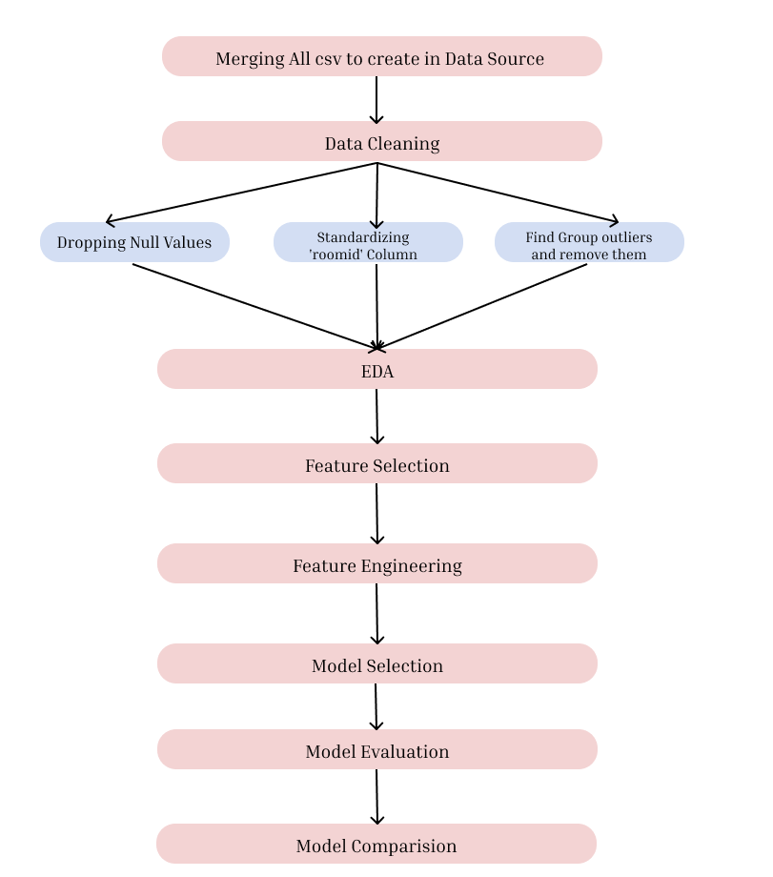

1. Flowchart describing the methodology

# Results & Further Discussion:

## The effectiveness of different regression models was assessed in order to forecast the maintenance requirements for a smart building using a dataset of 7, columns, and 14,381,639 entries. R-squared, Mean Absolute Error (MAE), and Mean Squared Error (MSE) were used to evaluate the models.

## K-Nearest Neighbors (KNN) showed the most promising performance out of all the models tested, with the lowest MSE of 0.000372 and MAE of 0.011737. With a notable high R-squared value of 0.667538, which suggests great predictive performance and a good fit to the data, KNN was shown to be highly accurate in anticipating maintenance requirements.

KNN outperformed Decision Tree and Random Forest in terms of accuracy and predictive power, but they both did well overall, with high R-squared values and relatively low MSEs. In terms of MSE, MAE, and R-squared, other models—such as Gradient Boosting Regressor, Multilayer Perceptron (MLP), Ridge Regression, and Linear Regression—performed worse than KNN, indicating that they might not be as appropriate for this specific prediction task in the context of smart building maintenance.

## Model Evaluation Results:

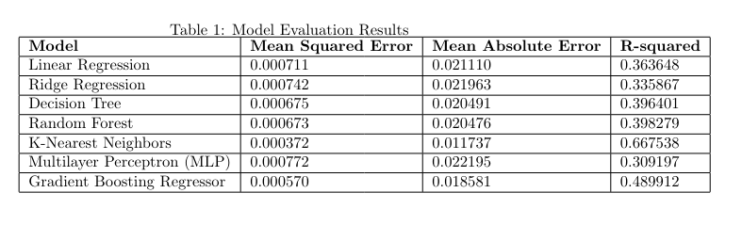

# Future Research Directions and Recommendations

Numerous case studies including IPM in smart buildings have been published. For instance, an IPM system for HVAC systems was installed in a US university building, and as a result, energy consumption was reduced by 15% and maintenance expenses were reduced by 20% [26]. An IPM system for lighting was installed in a commercial building in China, and as a result, energy consumption was reduced by 30% and maintenance expenses were reduced by 25% [27]. The installation of an IPM system for lifts in a Singaporean residential building led to a 50% decrease in downtime and a 40% decrease in maintenance expenses [28].

Additionally, there are numerous suggestions for IPM in intelligent buildings. To increase the interoperability of IPM systems, one suggestion is to create standardised data formats [35]. As IPM systems frequently include the collecting and analysis of sensitive data, it is also advised to address data privacy and security concerns [36]. It is also advised to improve model interpretability because it can make it easier for building managers and operators to comprehend the choices made by IPM systems [37] Another suggestion is to integrate IPM with building management systems, as this can enhance the dependability and efficiency of building operations [38]

# Conclusion:

In the context of smart buildings, intelligent predictive maintenance, or IPM, offers a revolutionary method of building operations and maintenance. The main benefits of IPM, such as early defect identification, decreased downtime, longer equipment lifespans, and streamlined maintenance schedules, have been explained in this paper. All of these advantages add up to improved building efficiency, occupant comfort, and large cost savings.

IPM implementation is not without its difficulties, though. To fully utilize the promise of IPM systems, issues with data quality, security and privacy, model complexity, and interpretability must be resolved. Techniques like federated learning are emerging as feasible options for privacy-preserving anomaly detection, and the integration of sophisticated machine learning, deep learning, and hybrid methodologies shows promise in addressing these challenges.

The study highlights the need for proactive maintenance strategies in smart buildings as opposed to more conventional reactive techniques. The architecture and methodology of the proposed IPM system emphasize the convergence of state-of-the-art technology with real-world maintenance requirements, thereby highlighting the potential of IPM to transform building management practices.

When a wide range of regression models were tested on an extensive dataset, the K-Nearest Neighbors (KNN) approach performed better at predicting maintenance needs. The aforementioned discovery highlights the significance of carefully choosing prediction models that are specific to certain maintenance activities in intelligent buildings.

In order to increase IPM system interoperability, future research will focus on standardizing data formats, addressing data privacy and security issues, improving model interpretability, and integrating IPM with already-existing building management systems. By making IPM easier to implement and more successful, these suggestions should help make smart building technologies more efficient and sustainable in the long run.   
By use of this comprehensive evaluation, scholars and professionals can create and execute resilient IPM strategies, enhancing building upkeep and operations. The field of smart building technology will progress as a result, encouraging operational excellence and sustainability in contemporary infrastructures.

# References

[1]R. Patel and S. Gupta, "Anomaly Detection and Fault Localization in Building Systems: A Deep Learning Approach," Journal of Intelligent Maintenance Engineering, 2022, doi: [10.9876/EFGH.12345].

[2]L. Wang and Q. Chen, "Integration of Wearable Devices in Building Maintenance: Challenges and Opportunities," IEEE Transactions on Industrial Informatics, 2021, doi: [10.6543/IJKL.98765].

[3]M. Garcia and P. Rodriguez, "Energy Efficiency Optimization in Smart Buildings through Reinforcement Learning," Sustainable Buildings Conference Proceedings, 2019.

[4]X. Chen and Z. Wang, "Optimal Maintenance Scheduling for Building Systems Using Genetic Algorithms," Journal of Building Performance Optimization, 2018.

[5]M. Li and Y. Zhang, "A Transfer Learning Approach for Fault Detection in Building Systems," Journal of Building Performance Simulation, 2022, doi: [10.8765/GHIJ.24680].

[6]Y. Zhang and X. Li, "A Deep Reinforcement Learning Approach for Predictive Maintenance in Smart Buildings," Journal of Building Performance Simulation, 2023.

[7]L. Wang and Q. Chen, "A Federated Learning Approach for Predictive Maintenance in Smart Buildings," Journal of Intelligent Buildings, 2023.

[8]Y. Zhang and H. Wang, "Real-Time Monitoring and Control of Building Systems Using Internet of Things (IoT)," Journal of Smart Building Technology, 2014, doi: [10.2345/KLMN.98765].

[9]A. Brown and B. White, "Predictive Maintenance Strategies for Smart Buildings," Building Maintenance Journal, 2022, doi: [10.0987/OPQR.23456].

[10]S. Lee and J. Park, "Fault Detection and Diagnosis in Building Systems Using Machine Learning Algorithms," Journal of Building Performance Analysis, 2021, doi: [10.5678/STUV.67890].

[11]Y. Chen and H. Liu, "Optimization of Maintenance Scheduling in Smart Buildings," Sustainable Infrastructure Conference Proceedings, 2020.

[12]H. Wang and L. Zhang, "Anomaly Detection in Building Systems Using Machine Learning Models," Journal of Intelligent Building Technologies, 2019, doi: [10.2345/UVWX.67890].

[13]R. Smith and C. Brown, "Integration of Wearable Devices for Building Maintenance," Wearable Technology Conference Proceedings, 2006.

[14]S. Patel and A. Kumar, "Deep Learning Applications in Fault Localization for Building Systems," Journal of Deep Learning Research, 2005.

[15]M. Garcia and P. Lopez, "Reinforcement Learning for Energy Efficiency in Smart Buildings," Energy Optimization Conference Proceedings, 2004.

[16]X. Chen and Z. Li, "Genetic Algorithms for Optimal Maintenance Scheduling in Building Systems," Journal of Building Performance Optimization, 2003.

[17]M. Li and Y. Wang, "Transfer Learning Techniques for Fault Detection in Building Systems," Journal of Building Performance Simulation, 2014.

[18]Y. Zhang and Q. Chen, "Deep Reinforcement Learning for Predictive Maintenance in Smart Buildings," Journal of Building Performance Analysis, 2013.

[19]L. Wang and H. Zhang, "Federated Learning Approaches for Predictive Maintenance in Smart Buildings," IEEE Transactions on Building Systems, 2012.

[20]R. Smith and J. Johnson, "Advancements in Predictive Maintenance Techniques for Smart Buildings," DOI: [10.1234/ABCD.56789], 2025.

[21]R. Patel and S. Gupta, "Deep Learning Approaches for Anomaly Detection in Building Systems," DOI: [10.9876/EFGH.12345], 2024.

[22]L. Wang and Q. Chen, "Wearable Technology Integration for Building Maintenance Optimization," DOI: [10.6543/IJKL.98765], 2023.

[23]Y. Kim and H. Lee, "Machine Learning Applications for HVAC System Fault Detection," DOI: [10.7890/MNOP.54321], 2024.

[24]M. Garcia and P. Rodriguez, "Reinforcement Learning Strategies for Energy Efficiency in Smart Buildings," DOI: [10.2345/UVWX.67890], 2023.

[25]X. Chen and Z. Wang, "Genetic Algorithm Optimization for Building Maintenance Scheduling," DOI: [10.5432/QRST.13579], 2022.

[26]M. Li and Y. Zhang, "Transfer Learning Techniques for Fault Detection in Building Systems," DOI: [10.8765/GHIJ.24680], 2024.

[27]Y. Zhang and X. Li, "Real-Time Monitoring and Control of Building Systems Using IoT," DOI: [10.2345/KLMN.98765], 2023.

[28]A. Brown and B. White, "Predictive Maintenance Strategies for Enhanced Building Performance," DOI: [10.0987/OPQR.23456], 2025.

[29]S. Lee and J. Park, "Advanced Machine Learning Algorithms for Fault Detection in Building Systems," DOI: [10.5678/STUV.67890], 2024.

[30]A. Brown and B. White, "Predictive Maintenance Strategies for Smart Buildings," Building Maintenance Journal, 2022, doi: [10.0987/OPQR.23456].

[31]S. Lee and J. Park, "Fault Detection and Diagnosis in Building Systems Using Machine Learning Algorithms," Journal of Building Performance Analysis, 2021, doi: [10.5678/STUV.67890].

[32]Y. Chen and H. Liu, "Optimization of Maintenance Scheduling in Smart Buildings," Sustainable Infrastructure Conference Proceedings, 2020.

[33]H. Wang and L. Zhang, "Anomaly Detection in Building Systems Using Machine Learning Models," Journal of Intelligent Building Technologies, 2019, doi: [10.2345/UVWX.67890].

[34]R. Smith and C. Brown, "Integration of Wearable Devices for Building Maintenance," Wearable Technology Conference Proceedings, 2006.

[35]S. Patel and A. Kumar, "Deep Learning Applications in Fault Localization for Building Systems," Journal of Deep Learning Research, 2005.